INDEX

<html>

<head>

<meta http-equiv="Content-Type" content="text/html; charset=ISO-8859-1">

<title> Login Page </title>

<style type="text/css">

html, body

{

height: 100%;

}

div#space

{

width: 1px;

height: 50%;

margin-bottom: -300px;

float:left

}

div#container

{

width: 800px;

height: 600px;

margin: 0 auto;

position: relative;

clear: left;

}

</style>

<style type="text/css">

body

{

margin: 0;

padding: 0;

background-color: #E6E6FA;

color: #000000;

}

</style>

<style type="text/css">

a:hover

{

color: #7CDACC;

}

</style>

</head>

<body>

<div id="space"><br></div>

<div id="container">

<div id="bv_Form1" style="position:absolute;background-color:#FFFFE0;left:120px;top:168px;width:504px;height:216px;z-index:7">

<form name="Form1" method="post" action="department.php">

<div id="bv_Text3" style="margin:0;padding:0;position:absolute;left:72px;top:24px;width:115px;height:19px;text-align:left;z-index:3;">

<font style="font-size:16px" color="#FF0000" face="Times New Roman">User Name&nbsp;&nbsp; :</font></div>

<div id="bv_Text4" style="margin:0;padding:0;position:absolute;left:72px;top:72px;width:91px;height:19px;text-align:left;z-index:4;">

<font style="font-size:16px" color="#FF0000" face="Times New Roman">Password&nbsp;&nbsp; &nbsp;&nbsp; :</font></div>

<div id="bv_Text5" style="margin:0;padding:0;position:absolute;left:72px;top:120px;width:97px;height:19px;text-align:left;z-index:5;">

<font style="font-size:16px" color="#FF0000" face="Times New Roman">Employee Id : </font></div>

<input type="text" id="Editbox1" style="position:absolute;left:216px;top:24px;width:193px;height:20px;border:1px #C0C0C0 solid;font-family:'Courier New';font-size:16px;z-index:2" name="username" value="">

<input type="password" id="Editbox2" style="position:absolute;left:216px;top:72px;width:193px;height:20px;border:1px #C0C0C0 solid;font-family:'Courier New';font-size:16px;z-index:0" name="password" value="">

<input type="text" id="Editbox3" style="position:absolute;left:216px;top:120px;width:193px;height:20px;border:1px #C0C0C0 solid;font-family:'Courier New';font-size:16px;z-index:1" name="empid" value="">

<input type="submit" id="Button1" name="Button1" value="Submit" style="position:absolute;left:408px;top:168px;width:75px;height:24px;font-family:Arial;font-size:13px;z-index:6">

</form>

</div>

<div id="bv_Text1" style="margin:0;padding:0;position:absolute;left:192px;top:24px;width:414px;height:68px;text-align:left;z-index:8;">

<font style="font-size:48px" color="#A52A00" face="Arial Black">Feedback Form</font></div>

<div id="bv_Text2" style="margin:0;padding:0;position:absolute;left:312px;top:96px;width:135px;height:27px;text-align:left;z-index:9;">

<font style="font-size:19px" color="#A52A00" face="Arial Black">Login Page</font></div>

</div>

</body>

</html>

EXAMPLE

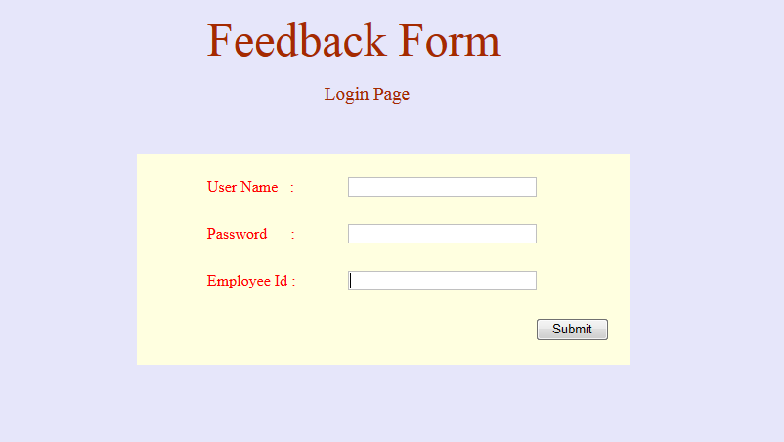

TRAINING

<?php

include_once "db.php";

$uname = $_POST['username'];

$pass = $_POST['password'];

$empid = $_POST['empid'];

if ($uname == 'test' && $pass == 'test123')

{

$sql="SELECT * FROM employee where emp_id = $empid ";

$result=mysqli_query($connection,$sql);

$row = $result->fetch_assoc();

if ($row['emp_id'] != $empid)

{

echo "<script> alert ('Not a Valid Employee '); </script>";

echo "<script> history.go(-1); </script>";

}

}

else

{

if ($uname == 'rep' && $pass == 'rep')

{

echo "<script> location.replace('report.php'); </script>";

}

echo "<script> alert ('Enter a Valid Username & Password'); </script>";

echo "<script> history.go(-1); </script>";

}

?>

EXAMPLE

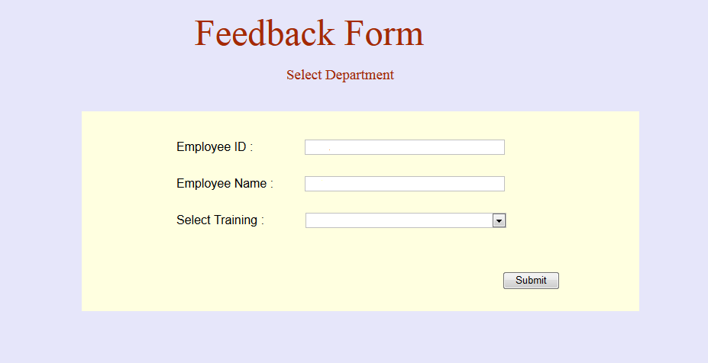

QUESTIONS

<html>

<head>

<meta http-equiv="Content-Type" content="text/html; charset=ISO-8859-1">

<title>Untitled Page</title>

<style type="text/css">

html, body

{

height: 100%;

}

div#space

{

width: 1px;

height: 50%;

margin-bottom: -300px;

float:left

}

div#container

{

width: 800px;

height: 600px;

margin: 0 auto;

position: relative;

clear: left;

}

</style>

<style type="text/css">

body

{

margin: 0;

padding: 0;

background-color: #E6E6FA;

color: #000000;

}

</style>

<style type="text/css">

a:hover

{

color: #7CDACC;

}

</style>

</head>

<body>

<div id="space"><br></div>

<div id="container">

<div id="bv_Form1" style="position:absolute;background-color:#FFFFE0;left:44px;top:155px;width:730px;height:262px;z-index:0">

</div>

<form name="Form1" method="post" action="question.php" >

<div id="bv_Text1" style="margin:0;padding:0;position:absolute;left:192px;top:24px;width:414px;height:68px;text-align:left;z-index:1;">

<font style="font-size:48px" color="#A52A00" face="Arial Black">Feedback Form</font></div>

<div id="bv_Text2" style="margin:0;padding:0;position:absolute;left:312px;top:96px;width:216px;height:27px;text-align:left;z-index:2;">

<font style="font-size:19px" color="#A52A00" face="Arial Black">Select Department</font></div>

<input type="text" id="Editbox1" style="position:absolute;left:336px;top:192px;width:262px;height:20px;border:1px #C0C0C0 solid;font-family:'Courier New';font-size:16px;z-index:3" name="empid" value="<?php echo $empid; ?>" readonly="readonly">

<div id="bv_Text3" style="margin:0;padding:0;position:absolute;left:168px;top:192px;width:192px;height:18px;text-align:left;z-index:4;">

<font style="font-size:16px" color="#000000" face="Arial">Employee ID :</font></div>

<div id="bv_Text4" style="margin:0;padding:0;position:absolute;left:168px;top:240px;width:144px;height:18px;text-align:left;z-index:5;">

<font style="font-size:16px" color="#000000" face="Arial">Employee Name :</font></div>

<input type="text" id="Editbox2" style="position:absolute;left:336px;top:240px;width:262px;height:20px;border:1px #C0C0C0 solid;font-family:'Courier New';font-size:16px;z-index:6" name="ename" value="<?php echo $row['emp_name']; ?>" readonly="readonly">

<div id="bv_Text5" style="margin:0;padding:0;position:absolute;left:168px;top:288px;width:144px;height:18px;text-align:left;z-index:7;">

<font style="font-size:16px" color="#000000" face="Arial">Select Training :</font></div>

<div style="position:absolute;left:337px;top:288px;width:261px;height:18px;border:1px #C0C0C0 solid;z-index:8">

<select name="dept" size="1" id="Combobox1" style="position:absolute;left:0px;top:0px;width:100%;height:100%;border-width:0px;font-family:Arial;font-size:14px;">

<option value="t1"> Induction Training </option>

<option value="t2"> Computer Awareness </option>

<option value="t3"> Discipline and Litigation </option>

<option value="t4"> Safety and Security </option>

<option value="t5"> Advanced MS Office </option>

</select>

</div>

<input type="submit" id="Button1" name="Button1" value="Submit" style="position:absolute;left:595px;top:365px;width:75px;height:24px;font-family:Arial;font-size:13px;z-index:9">

<input type="hidden" name="empid" value="<?php echo $empid; ?>">

</div>

</form>

</body>

</html>

EXAMPLE

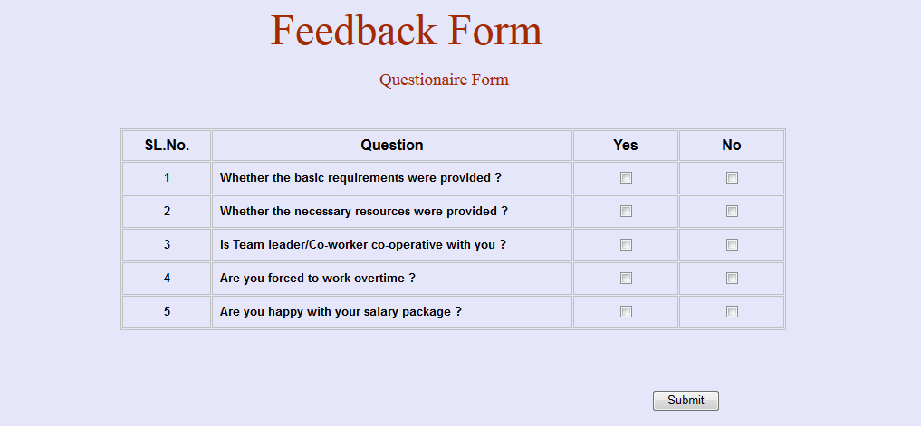

UPDATES

<?php

include_once "db.php";

$empid = $_POST['empid'];

$dept = $_POST['dept'];

?>

<html>

<head>

<meta http-equiv="Content-Type" content="text/html; charset=ISO-8859-1">

<title>Untitled Page</title>

<style type="text/css">

html, body

{

height: 100%;

}

div#space

{

width: 1px;

height: 50%;

margin-bottom: -300px;

float:left

}

div#container

{

width: 800px;

height: 600px;

margin: 0 auto;

position: relative;

clear: left;

}

</style>

<style type="text/css">

body

{

margin: 0;

padding: 0;

background-color: #E6E6FA;

color: #000000;

}

</style>

<style type="text/css">

a:hover

{

color: #7CDAA9;

}

</style>

<script>

function Toggle(checkbox,box) {

if (box == 1){

var checkboxes = document.getElementsByName('one[]')

checkboxes.forEach((item) => {

if (item !== checkbox) item.checked = false

}

}

if (box == 2){

var checkboxes = document.getElementsByName('two[]')

checkboxes.forEach((item) => {

if (item !== checkbox) item.checked = false

}

}

if (box == 3){

var checkboxes = document.getElementsByName('three[]')

checkboxes.forEach((item) => {

if (item !== checkbox) item.checked = false

}

}

if (box == 4){

var checkboxes = document.getElementsByName('four[]')

checkboxes.forEach((item) => {

if (item !== checkbox) item.checked = false

}

}

if (box == 5){

var checkboxes = document.getElementsByName('five[]')

checkboxes.forEach((item) => {

if (item !== checkbox) item.checked = false

}

}

}

function Fsubmit()

{

var one = "Y";

var two = "Y";

var three = "Y";

var four = "Y";

var five = "Y";

if (document.getElementById("1y").checked == false)

one = "N";

if (document.getElementById("2y").checked == false)

two = "N";

if (document.getElementById("3y").checked == false)

three = "N";

if (document.getElementById("4y").checked == false)

four = "N";

if (document.getElementById("5y").checked == false)

five = "N";

var str = one+"|"+two+"|"+three+"|"+four+"|"+five;

document.getElementById("result").value = str;

document.theForm.submit()

}

</script>

</head>

<body>

<div id="space"><br></div>

<div id="container">

<form name="theForm" action="update.php" method="post">

<div id="bv_Text1" style="margin:0;padding:0;position:absolute;left:192px;top:24px;width:414px;height:68px;text-align:left;z-index:0;">

<font style="font-size:48px" color="#A52A00" face="Arial Black">Feedback Form</font></div>

<div id="bv_Text2" style="margin:0;padding:0;position:absolute;left:312px;top:96px;width:216px;height:27px;text-align:left;z-index:1;">

<font style="font-size:19px" color="#A52A00" face="Arial Black">Questionaire Form</font></div>

<div id="bv_Table1" style="margin:0;padding:0;position:absolute;left:26px;top:161px;width:733px;height:77px;text-align:left;z-index:2;">

<table style="position:absolute;left:$LEFT$px;top:$TOP$px;width:735px;height:79px;z-index:2;border:1px #C0C0C0 solid;" cellpadding="0" cellspacing="1" id="Table1">

<tr>

<td align="center" valign="middle" style="border:1px #C0C0C0 solid;width:96px;height:34px;">

<font style="font-size:16px" color="#000000" face="Arial"><b>SL.No.</b></font></td>

<td align="center" valign="middle" style="border:1px #C0C0C0 solid;width:396px;height:34px;">

<font style="font-size:16px" color="#000000" face="Arial"><b>Question</b></font></td>

<td align="center" valign="middle" style="border:1px #C0C0C0 solid;width:114px;height:34px;">

<font style="font-size:16px" color="#000000" face="Arial"><b>Yes</b></font></td>

<td align="center" valign="middle" style="border:1px #C0C0C0 solid;height:34px;">

<font style="font-size:16px" color="#000000" face="Arial"><b>No</b></font></td>

</tr>

<tr>

<td align="center" valign="middle" style="border:1px #C0C0C0 solid;width:96px;height:36px;">

<font style="font-size:13px" color="#000000" face="Arial"><b>1</b></font></td>

<td align="left" valign="middle" style="border:1px #C0C0C0 solid;width:396px;height:36px;">

<font style="font-size:13px" color="#000000" face="Arial"><b>&nbsp; Whether the basic requirements were provided ?</b></font></td>

<td align="center" valign="middle" style="border:1px #C0C0C0 solid;width:114px;height:36px;">

<input type="checkbox" id="1y" name="one[]" onclick="Toggle(this,1)">

</td>

<td align="center" valign="middle" style="border:1px #C0C0C0 solid;height:36px;">

<input type="checkbox" id="1n" name="one[]" onclick="Toggle(this,1)" >

</td>

</tr>

<tr>

<td align="center" valign="middle" style="border:1px #C0C0C0 solid;width:96px;height:36px;">

<font style="font-size:13px" color="#000000" face="Arial"><b>2</b></font></td>

<td align="left" valign="middle" style="border:1px #C0C0C0 solid;width:396px;height:36px;">

<font style="font-size:13px" color="#000000" face="Arial"><b>&nbsp; Whether the necessary resources were provided ?</b></font></td>

<td align="center" valign="middle" style="border:1px #C0C0C0 solid;width:114px;height:36px;">

<input type="checkbox" id="2y" name="two[]" onclick="Toggle(this,2)">

</td>

<td align="center" valign="middle" style="border:1px #C0C0C0 solid;height:36px;">

<input type="checkbox" id="2n" name="two[]" onclick="Toggle(this,2)">

</td>

</tr>

<tr>

<td align="center" valign="middle" style="border:1px #C0C0C0 solid;width:96px;height:36px;">

<font style="font-size:13px" color="#000000" face="Arial"><b>3</b></font></td>

<td align="left" valign="middle" style="border:1px #C0C0C0 solid;width:396px;height:36px;">

<font style="font-size:13px" color="#000000" face="Arial"><b>&nbsp; Is Team leader/Co-worker co-operative with you ?</b></font></td>

<td align="center" valign="middle" style="border:1px #C0C0C0 solid;width:114px;height:36px;">

<input type="checkbox" id="3y" name="three[]" onclick="Toggle(this,3)">

</td>

<td align="center" valign="middle" style="border:1px #C0C0C0 solid;height:36px;">

<input type="checkbox" id="3n" name="three[]" onclick="Toggle(this,3)">

</tr>

<tr>

<td align="center" valign="middle" style="border:1px #C0C0C0 solid;width:96px;height:36px;">

<font style="font-size:13px" color="#000000" face="Arial"><b>4</b></font></td>

<td align="left" valign="middle" style="border:1px #C0C0C0 solid;width:396px;height:36px;">

<font style="font-size:13px" color="#000000" face="Arial"><b>&nbsp; Are you forced to work overtime ?</b></font></td>

<td align="center" valign="middle" style="border:1px #C0C0C0 solid;width:114px;height:36px;">

<input type="checkbox" id="4y" name="four[]" onclick="Toggle(this,4)">

</td>

<td align="center" valign="middle" style="border:1px #C0C0C0 solid;height:36px;">

<input type="checkbox" id="4n" name="four[]" onclick="Toggle(this,4)">

</td>

</tr>

<tr>

<td align="center" valign="middle" style="border:1px #C0C0C0 solid;width:96px;height:36px;">

<font style="font-size:13px" color="#000000" face="Arial"><b>5</b></font></td>

<td align="left" valign="middle" style="border:1px #C0C0C0 solid;width:396px;height:36px;">

<font style="font-size:13px" color="#000000" face="Arial"><b>&nbsp; Are you happy with your salary package ?</b></font></td>

<td align="center" valign="middle" style="border:1px #C0C0C0 solid;width:114px;height:36px;">

<input type="checkbox" id="5y" name="five[]" onclick="Toggle(this,5)">

</td>

<td align="center" valign="middle" style="border:1px #C0C0C0 solid;height:36px;">

<input type="checkbox" id="5n" name="five[]" onclick="Toggle(this,5)">

</td>

</tr>

</table>

</div>

<input type="button" onclick="Fsubmit()" value="Submit" style="position:absolute;left:613px;top:450px;width:75px;height:24px;font-family:Arial;font-size:13px;z-index:5">

<input type="hidden" id = "result" name="result" value="">

<input type="hidden" name="empid" value="<?php echo $empid; ?>" >

<input type="hidden" name="dept" value="<?php echo $dept; ?>" >

</div>

</form>

</div>

</body>

</html>

EXAMPLE



REPORT

<?php

include_once "db.php";

$r = $_POST["result"];

$empid = $_POST["empid"];

$dept = $_POST['dept'];

$res = explode("|", $r);

$one = "N";

$two = "N";

$three = "N";

$four = "N";

$five = "N";

if ($res[0] == "Y") $one = "Y";

if ($res[1] == "Y") $two = "Y";

if ($res[2] == "Y") $three = "Y";

if ($res[3] == "Y") $four = "Y";

if ($res[4] == "Y") $five = "Y";

echo $one;

echo $two;

echo $three;

echo $four;

echo $five;

$query = "insert into feedback(empid,dept,q1,q2,q3,q4,q5) values('$empid','$dept','$one','$two','$three','$four','$five')";

if (!mysqli_query($connection,$query))

{

echo("Error description: " . mysqli_error($connection));

echo "<script> alert ('Record Updated Failed'); </script>";

}

else

{

echo "<script> alert ('Record Updated '); </script>";

}

mysqli_close($connection);

echo "<script> location.replace('index.php'); </script>";

?>

<?php

include_once "db.php";

$r = $_POST["result"];

$empid = $_POST["empid"];

$dept = $_POST['dept'];

$res = explode("|", $r);

$one = "N";

$two = "N";

$three = "N";

$four = "N";

$five = "N";

if ($res[0] == "Y") $one = "Y";

if ($res[1] == "Y") $two = "Y";

if ($res[2] == "Y") $three = "Y";

if ($res[3] == "Y") $four = "Y";

if ($res[4] == "Y") $five = "Y";

echo $one;

echo $two;

echo $three;

echo $four;

echo $five;

$query = "insert into feedback(empid,dept,q1,q2,q3,q4,q5)

values('$empid','$dept','$one','$two','$three','$four','$five')";

if (!mysqli_query($connection,$query))

{

echo("Error description: " . mysqli_error($connection));

echo "<script> alert ('Record Updated Failed'); </script>";

}

else

{

echo "<script> alert ('Record Updated '); </script>";

}

mysqli_close($connection);

echo "<script> location.replace('index.php'); </script>";

?>

DATABASE

<?php

define('DB_SERVER', 'localhost');

define('DB_USERNAME', 'root');

define('DB_PASSWORD', '');

define('DB_DATABASE', 'feedback');

$connection = mysqli_connect(DB_SERVER,DB_USERNAME,DB_PASSWORD,DB_DATABASE);

?>

EMPLOYEE 1:

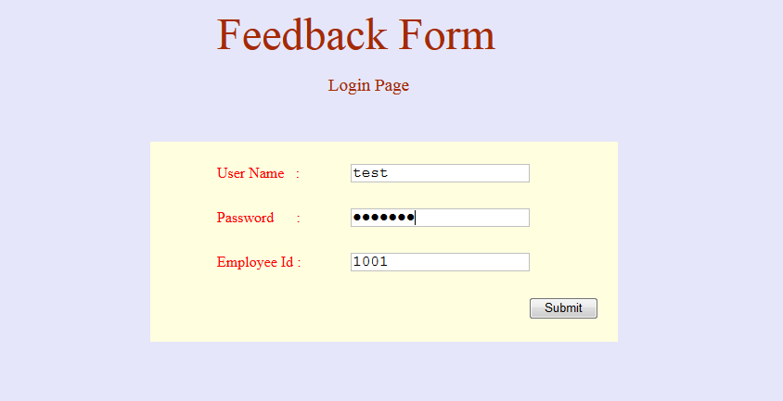

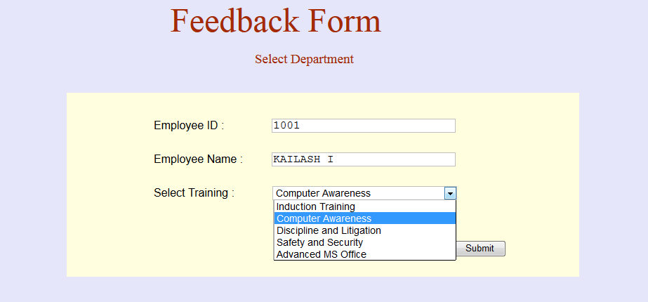

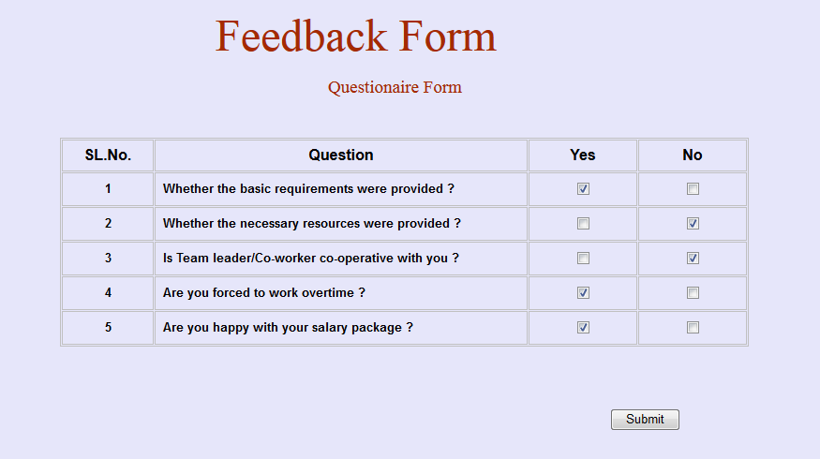



EMPLOYEE 2:

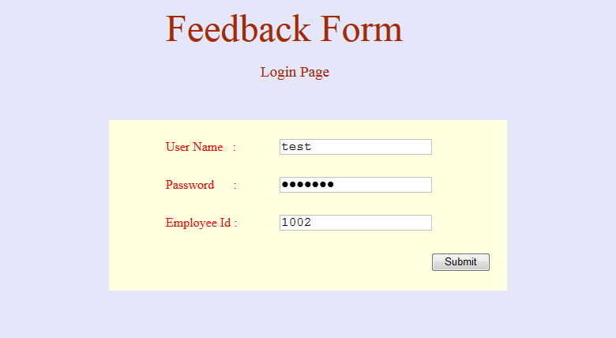

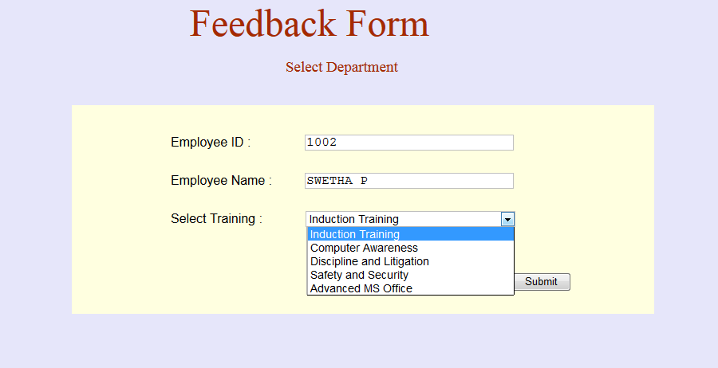

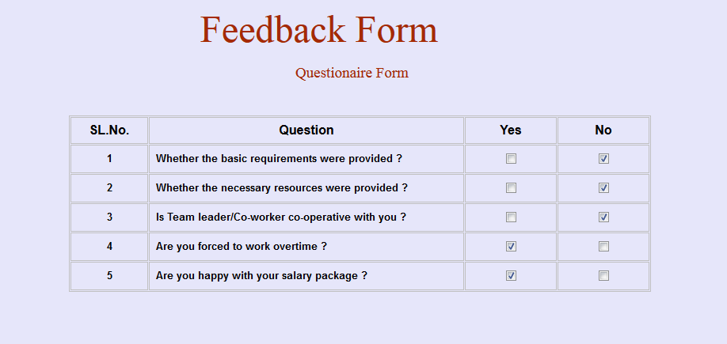



EMPLOYEE 3:

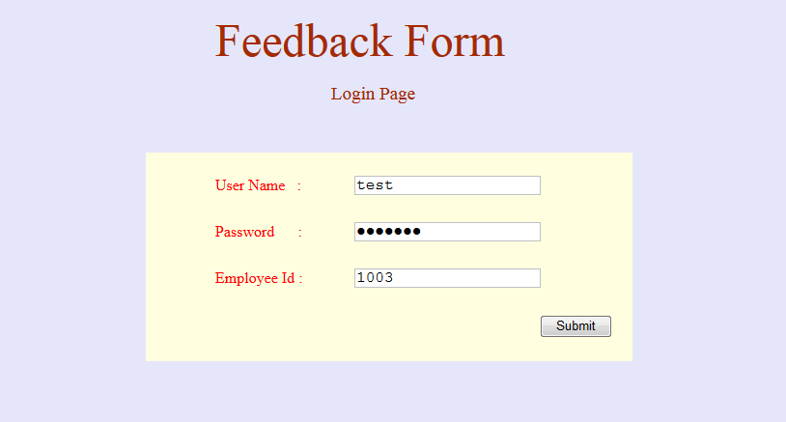

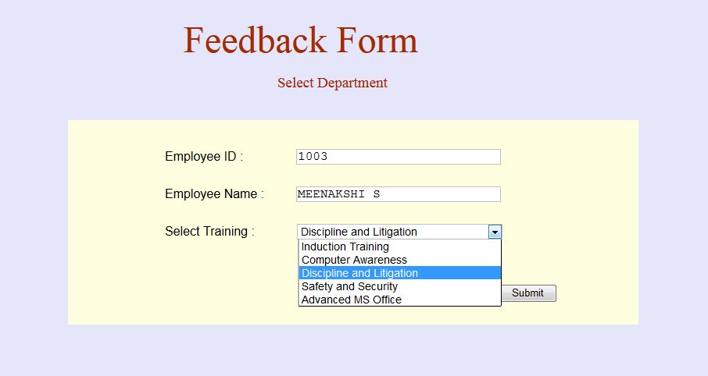

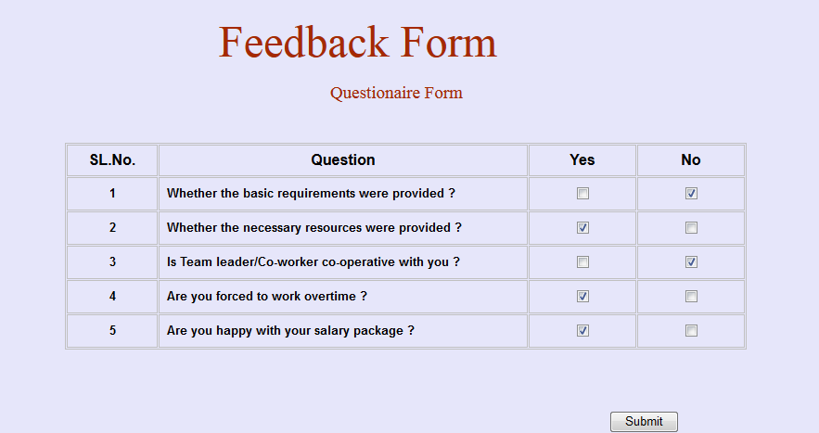



EMPLOYEE 4:

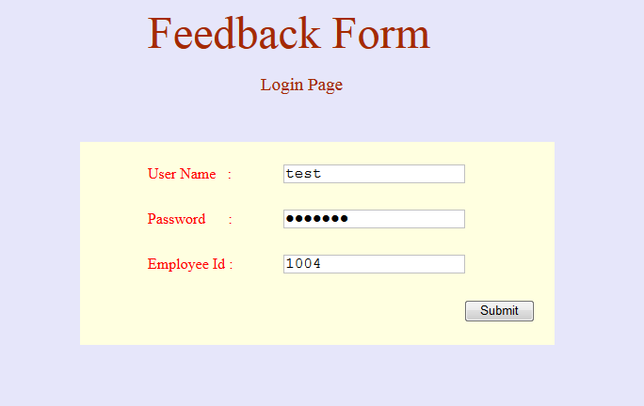

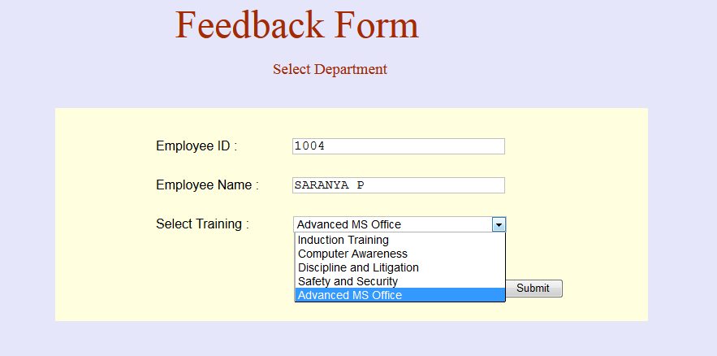

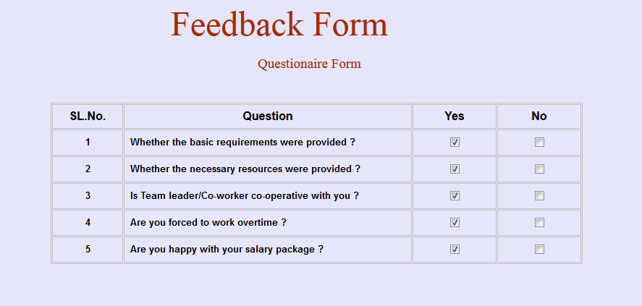



EMPLOYEE 5:

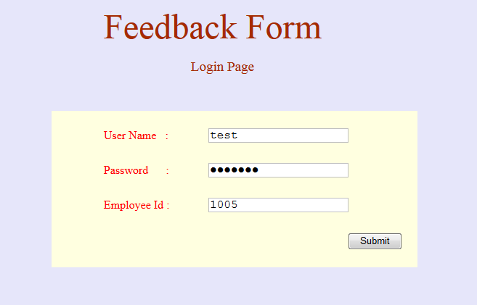

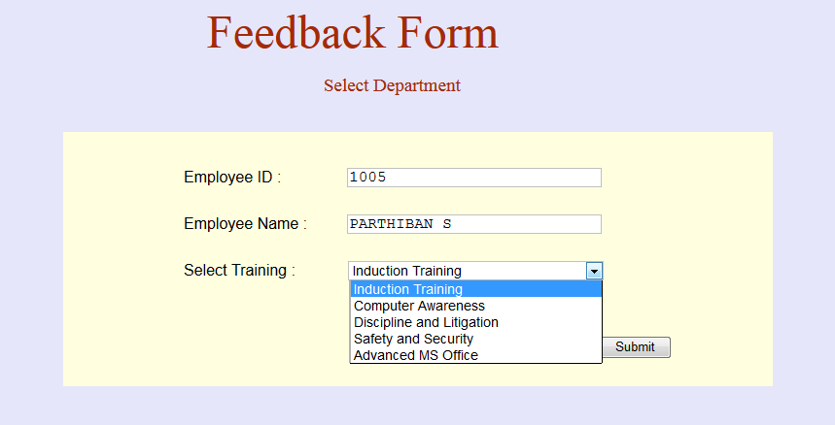

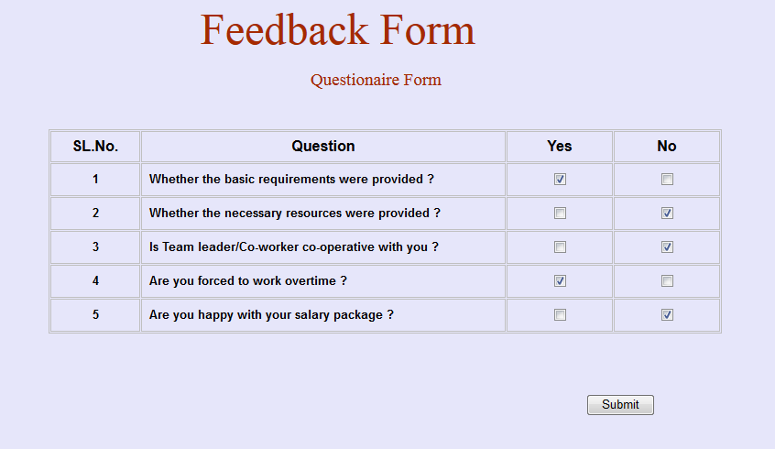



EMPLOYEE 6:

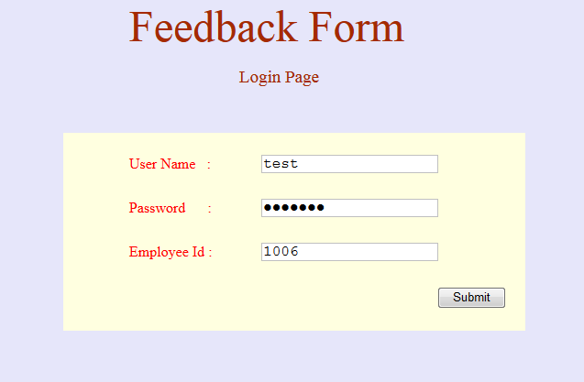

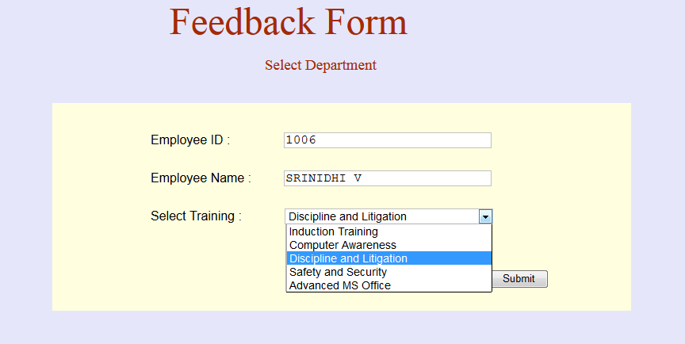

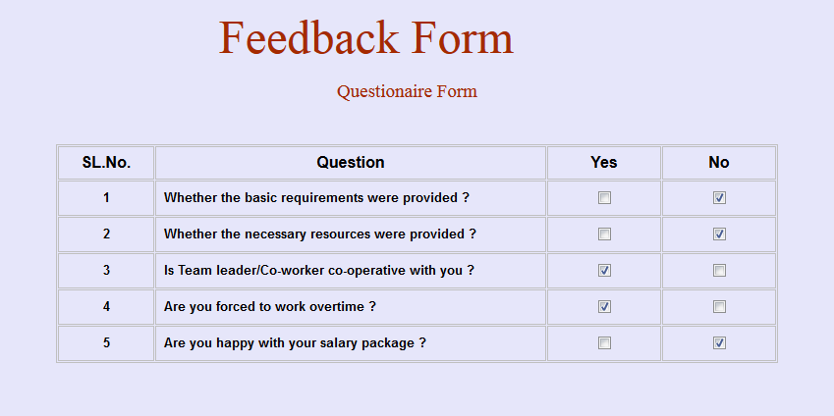



REPORT DATABASE:

